
Hazmat Guidelines and Issues
Hazmat Issues:
Volume 49 of the Code of Federal Regulations, Section 172.704 (49 CFR 172.704) stipulates that Hazmat employee training must include:
General awareness familiarization training.
Function specific training.
Safety training.
Security awareness training.

The Code of Federal Regulations (CFR) requires that a Hazmat employee receive training at least once every three years. (49 CFR 172.704)

CFR Title 49 180.205(c) , 173.301(a)(6) stipulates that no cylinder may be filled and transported unless it has been successfully and periodically re-qualified.

Except as otherwise provided by the CFR, each time a cylinder is pressure tested, it must be given both an internal and external visual inspection.

The visual inspection must be performed in accordance with the following CGA pamphlets:
C-6 // C-8 // C-13

The water jacket method: 1.) is a volumetric expansion test; 2.) Determines a cylinder’s total expansion; 3.) Determines a cylinder’s permanent expansion; and 4.) Measures a difference in water volume displacement.
The expansion-indicating device, as part of a water-jacket retesting system, must be stable and have an accuracy of ± 0.5%, or better, of its full scale.
Percent permanent expansion is a function of permanent expansion divided by total expansion times 100. 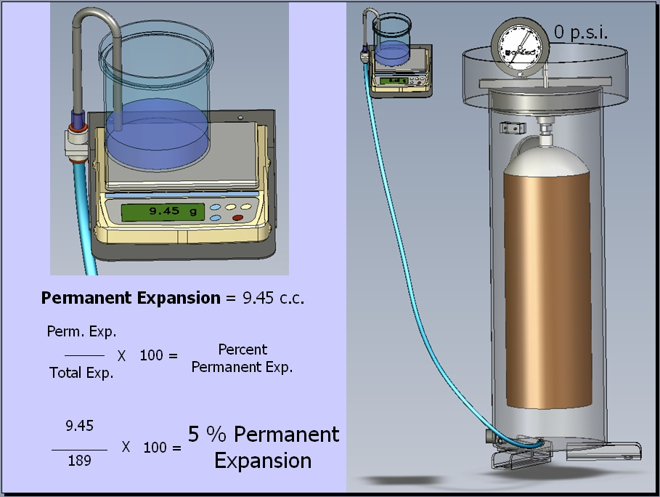

The direct expansion method calculates a cylinder’s total and permanent expansion.

A proof pressure test does not determine a cylinder’s expansion.

In the event of equipment malfunction, the test may be repeated at a pressure increased by 10% or 100 psig., whichever is less
A system check may be performed at or below 90% of test pressure, prior to the retest.

Total expansion minus permanent expansion equals elastic expansion. 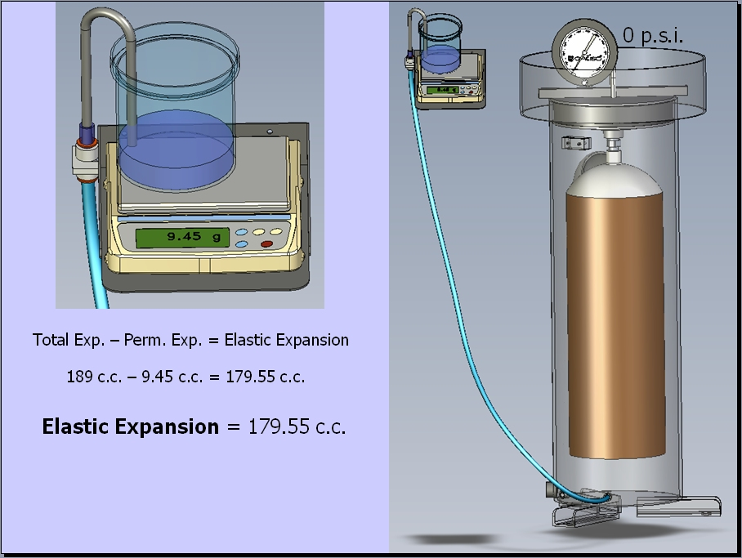

A D.O.T. specification cylinder must be condemned when permanent expansion exceeds 10 percent of total expansion.

A cylinder must be condemned when evidence of cracking exists to the extent that the cylinder is likely to be weakened appreciably.

Re-qualifiers must mark condemned cylinders using one of the following manners:
Either stamp a series of Xs over the D.O.T. specification number and the marked pressure OR
Stamp “CONDEMNED” on the shoulder, top head, or neck using a steel stamp.
Condemned composite cylinders must have a label with the word “CONDEMNED” over-coated with epoxy securely affixed.

As an alternative to stamping or labeling, a re-qualifier may render a cylinder incapable of holding pressure.

When condemned, a re-qualifier must notify the cylinder owner, in writing, that the cylinder is condemned.

When a cylinder is condemned, the cylinder owner must be further notified in writing that the cylinder may not be filled with hazardous material and offered for transportation in commerce.

Permanent expansion means a permanent increase in the cylinder’s volume after the test pressure is released.

For a DOT specification cylinder other than a DOT 4E aluminum cylinder or an exemption cylinder, a cylinder must be condemned when permanent expansion exceeds 10% of total expansion.

The CFR allows that any cylinder not exceeding 2 inches outside diameter and less than 2 feet in length is excepted from volumetric expansion testing.

An increase in elastic expansion indicates a reduction in the average wall thickness.

A cylinder will no longer qualify for service at 110% of rated pressure (i.e. a “+”) when:
The elastic expansion exceeds the limit established by the owner OR
The wall stress at service pressure exceeds the limits established by the CFR.

If a test is repeated due to equipment or operator error, the cumulative increase shall be limited to no more than 10% of minimum prescribed test pressure.

Foreign cylinders may be used in the U.S. if:
The cylinder has been requalified in accordance with the CFR
Density, pressure and relief devices are in keeping with the CFR
Bill of lading or shipping papers identify the cylinder
The cylinder has been certified as being qualified by DOT for export

The CFR establishes the minimum test pressure for requalification of foreign cylinders to be as marked, but not less than 5/3 of any service or working pressure marking.

The Hazardous Material Safety Administration provides that DOT-3HT specification cylinders are authorized for aircraft use only.

The Hazardous Materials Regulations (HMR) prescribes the requalification requirements for DOT-3HT cylinders.

In accordance with the CFR, a cylinder marked DOT-3HT must be re-qualified in accordance with CGA C-8 pamphlet.

Canadian and U.S. cylinders may NOT be exchanged and freely used in commercial transport in both the U.S. and Canada respectively.

Canadian cylinders may be used within the U.S. under the following conditions:
The Canadian Transport Commission (CTC) corresponds with a D.O.T. specification.
The cylinder has been re-qualified under a program authorized by Canadian TDG regulations.
The cylinder has been requalified in accordance with D.O.T. specifications.

D.O.T. 3HT Cylinders must be condemned if the elastic expansion exceeds the Rejection Elastic Expansion (REE) as marked on the cylinder.

Aluminum alloy 6351-T6 cylinders used in SCUBA, SCBA or oxygen service must be re-qualified using an Eddy Current Examination combined with a visual inspection.

The pressure indicating device of the testing apparatus must permit reading of pressures:
To within 1% of the minimum prescribed test pressure of each cylinder tested and
Interpolation to ½ of the marked gauge divisions is acceptable for an analog device.

Requalification marking on a cylinder used as a dry chemical fire extinguisher may be by means of a pressure sensitive label. Other cylinders must use permanent marking (other than stamping a composite).

A dry chemical fire extinguisher may not contain more than 30% Carbon Dioxide by volume or any other corrosive extinguishing agent.

When specific conditions are met, previous requalification markings may be obliterated. - CFR 180.213

CFR Title 49, stipulates that visual inspection must be performed in accordance with CGA pamphlets, series C-6, and that is where criteria for neck and thread defects are outlined.

Without regard to any other periodic requalification requirements, a cylinder may be required to be tested and re-inspected.

A cylinder must be retested if it shows evidence of any condition that might render it unsafe for use in transportation.

If a cylinder shows evidence of or is known to have been over-heated, it must be be retested in accordance with the CFR.

A person who re-qualifies cylinders must maintain records at each location at which it inspects, tests, or marks cylinders.

A cylinder filled before requalification becomes due may remain in service until it is emptied.

Here is the information you need for each phase of the process of complying with regulations and becoming a professionally-trained and well-equipped test facility:
- Contact the Department of Transportation (D.O.T.): To start the D.O.T. registration and certification process, contact the D.O.T. Approvals Branch in Washington D.C., (202) 366-4512, and request a documentation packet. This contains the necessary papers and a listing of Third-Party Inspection Agents whom you must contact to arrange an on-site inspection of your facilities after the system is installed. The agent will evaluate and verify that you are properly equipped, staffed, and trained to be in compliance with D.O.T. requirements. You may also select a list of 3rd Party Inspectors at the Galiso website (www.galiso.com ) under “Information” in the navigation bar.
Upon completion, the 3rd Party Inspector provides you with a letter of recommendation, and the Approvals Branch with an inspection report. Your company must then submit the letter and completed application to the Approvals Branch of the D.O.T. to obtain the Retester’s Identification Number (RIN). Notification that you may begin approved testing usually takes from 10 to 14 days.

- Order required documentation: The following publications are essential to comply with regulatory standards and must be present at all times for reference:

A copy of the U.S. Code of Federal Regulations (CFR), Title 49, Parts 180.200-215 and related sections can be obtained from the Superintendent of Documents, U.S. Government Printing Office, Washington, D.C. 20402.
Compressed Gas Association (CGA) required cylinder testing and inspection pamphlets C-1, C-5, C-6, C-6.1, C-6.2, C-6.3 and C-8 are available for purchase from Galiso or directly from the CGA by contacting them at (703) 788-2700.

The Compressed Gas Association (Tel: 703-788-2700) in their pamphlet CGA C-1.1 entitled “Personnel Training and Certification Guidelines for Cylinder Requalification by the Volumetric Expansion Method” provides guidelines for training and certifying individuals responsible for the requalification of cylinders by the volumetric expansion method. This important pamphlet outlines the Training / Certification Process; the Requirements of a requalification facility; Required Documents and Publications; General Requirements for Program Management, Testing, Visual Inspection, Cylinder Marking and Record Keeping in addition to references and CGA sample test questions.

- Enroll for Hazmat Training: Re-testers are required to have training designed to fulfill the initial and the three-year recurrent training requirement of 49 CFR 172.704(a)(1)&(2) General Awareness and Function Specific Training for Cylinder Retest Operators. Galiso recommends hazmat training available from CTC Seminars (www.ctcseminars.com ).

Galiso also provides hazmat awareness training and training regarding Galiso equipment online at the Galiso website (www.galiso.net/Training/GalisoTraining.html ).
Our Hazmat Awareness Certification Test is not a complete Hazmat training test at this time and we do not recommend that you use this test to consider yourself “Hazmat Trained”. We hope that this test will increase your understanding of certain Hazmat issues and that you will provide input to us to improve this test. We desire to work with you to improve the safety, accuracy and efficiency of compressed gas cylinder qualification practices worldwide.
For complete Hazmat training we recommend training from CTC Seminars - http://www.ctcseminars.com . Darrell Garton has developed an excellent Hazmat training seminar there is no other program that we are aware of that provides the level of training that his 2 day seminar offers.
A Galiso training certificate will show:
- Identification of training: Certification of “Online Hazmat Awareness”
- Date of issuance.
- Name of Trainee.
- Requalification company name and address.
- Training program manager’s name and signature.
- Expiration date (valid for a period not to exceed 3 years)

- Test Pit completed
- Air, Water, Electrical in place
- On-Site System Installation
- 3rd Party Inspection completed
- Submit application to D.O.T.
- Receive Retester’s Identification Number (RIN)
- Hold Open House!

Along the way a question regarding compliance may pop up, or an operator may have difficulty with a particular cylinder. Galiso’s customer service department will step you through a procedure, analyze and troubleshoot a problem, and offer solutions to a myriad of situations. Call us toll free at 800-854-3789 or you may use (970) 249-0233. You may also e-mail our customer service department at: custsvc@galiso.com or our sales department at: sales.galiso@galiso.com .

