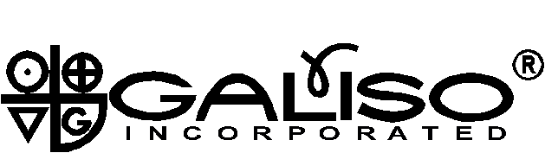
22 Ponderosa Court, Montrose, CO 81401
Tel. (970) 249-0233 Fax (970) 249-0607
custsvc@galiso.com

Galiso Incorporated in cooperation with CTC are again offering two valuable seminars in one great location!

Galiso Production/Maintenance Seminar

September 18th & September 19th, 2007

And the

CTC HAZMAT Seminar

September 20th & September 21st, 2007

In Beautiful Montrose, Colorado

It’s time to make plans to attend one or both of these valuable seminars that have been scheduled back-to-back for your convenience.

The two-day Galiso Production/Maintenance Seminar gives you an opportunity to gain hands-on Test System experience. You will learn ways to increase production and shorten down time as you become more proficient in; testing techniques, trouble shooting/problem solving and actually repairing test heads and pumps.

The Galiso Family would like to extend this personal invitation to come meet us and enjoy our Colorado hospitality while you gain insight into Galiso test systems and equipment.

The cost for each seminar is $325.00, or you may register for both seminars for $650.00. Attendees are responsible for providing their own Hotel Accommodations and Transportation.

To request a registration form and information call:
Galiso at 1-800 854-3789 and ask for Chris Storeng in Customer Service, or call CTC and ask for Darrell Garton at 970-240-3391. Act soon, these seminars fill to capacity quickly.

