AZ Pump Instructions
PUMP NOT RUNNING PROPERLY: Check to be sure air pressure is reaching the pump, check to be sure air filter is not clogged; clean or replace as required. Check to be sure fluid filter is not clogged; clean or replace as required. If the actions do not remedy operations, a general maintenance repair may be required
A REPAIR KIT PART NUMBER 38-11-3084 IS AVAILABLE AND CONTAINS ALL THE PARTS NORMALLY REPLACED DURING A STANDARD MAINTENANCE REPAIR.
GENERAL NOTE: Before installation of new parts, all o’ rings, seals, and bumpers should be lubricated with silicone grease, Vaseline or other suitable lubricant.
TO REPLACE THE PACKING IN THE HYDRAULIC CYLINDER: It is not necessary to dismantle the Air Motor. Proceed as follows:
Air Motor Assembly
Disconnect the air supply line.
Unscrew the Air Motor from the hydraulic cylinder, the Hydraulic Piston, Will be removed with the Air Motor. 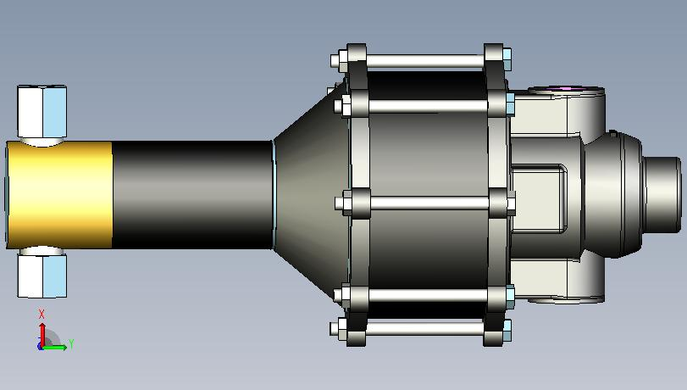
Hydraulic cylinder
The packing, P/N 40-11-3033 consisting of 1 each o- ring and 2 each Teflon backup Rings, can new be removed and new parts installed. 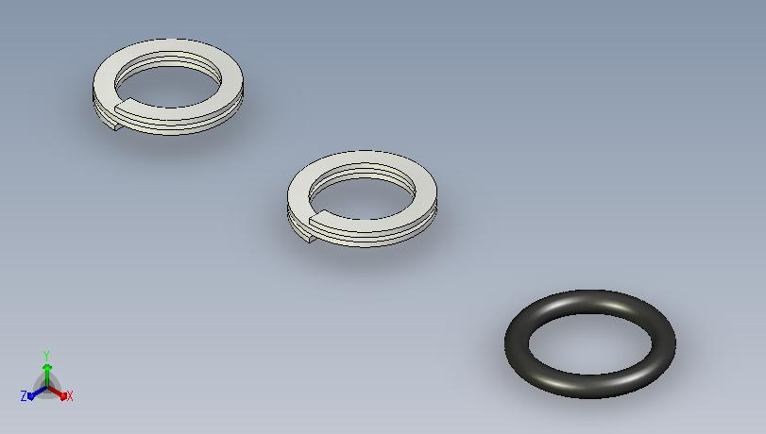 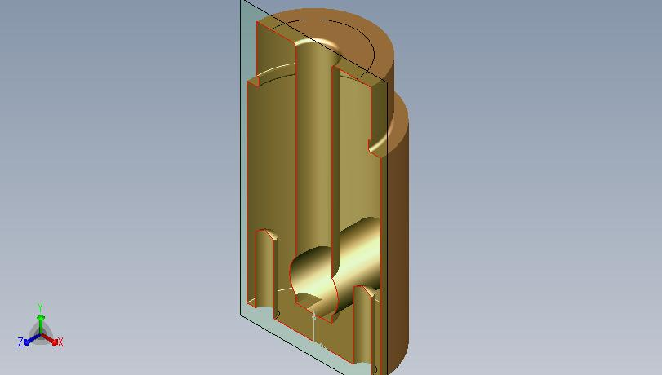
When replacing the Air Motor, install a new gasket, if necessary.
Tighten the Air Motor securely to proper position.
Seals will be located here Kit P/N 40-11-3033
Air Motor assembly
Seal Kit P/N 40-11-3033

TO DISASSEMBLE THE AIR MOTOR: refer to this Parts List, proceed as follows: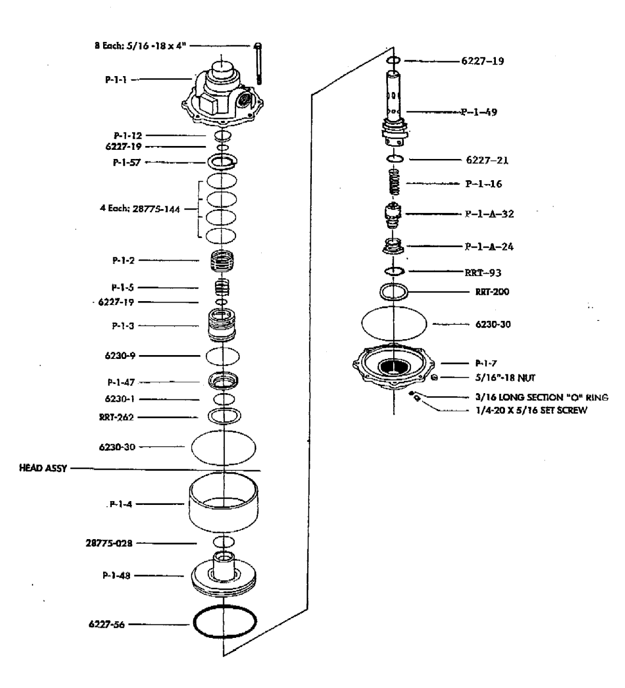
Disconnect the air supply line.
Remove the eight (8) 5/16” bolts around the outside diameter.
To remove the hydraulic piston (P-1-1-140), from the Air Piston,(P-1-48) remove the retaining ring.
The pilot valve assembly (P-1-60), can now be pushed out through the bottom of the Air Piston. Remove the retaining ring (RRT-262) from the head assembly and remove the bearing Assembly (P-1-47), by lifting or prying it out with a hammer handle or similar tool. (The Bearing Assembly has a molded rubber seat on one side, if the rubber is damaged, a new bearing assembly should be installed).
The valve, (P-l-3), can now be removed. Remove the spring, (P-1-5). The head casting, (P-1-1), has a rubber bumper, (P-1-57), inserted in the upper portion of the body. This bumper acts as a seal and cushion for the valve and should be replaced if worn or damaged.
NOTE: when worn or damaged, the valve, (P-1-3), and the Sleeve, (P-1-2), in which the valve operates can be replaced with a new Valve Assembly, (P-1-111). If installing a new valve assembly, install a new set of o-rings, (28775-144), 4 are required and are included when a replacement assembly is ordered. CAUTION: DO NOT REMOVE the sleeve (P-l-2), unless a replacement valve assembly is being installed. The valve and sleeve are ground and honed to a very close tolerance and the Sleeve may be damaged when removed from the head casting.

TO REPAIR THE PILOT VALVE ASSEMBLY: (P-1-60), Remove the retaining ring, (RRT-93). Using a spanner wrench or needle nose pliers, remove the seat, (P-1-A-24). The air check assembly, (P-1-A-32), and the spring, (P-1-16), will then drop out and may be inspected for wear or damage. Replace worn or damaged parts and reassemble

TO REPAIR THE HYDRAULIC CHECK VALVES: refer to the Parts List
INLET VALVE ASSEMBLY (P-1-29): remove the internal parts, inspect and replace required. Remove the o-ring, (6227-890 Shore), inspect the ball seat n the check valve body (P-1-21). If worn or damaged a new body should be used. Install a new o-ring, (6227-890 Shore), replace the internal parts and secure the assembly by installing on the hydraulic cylinder, (P-1-11-140)
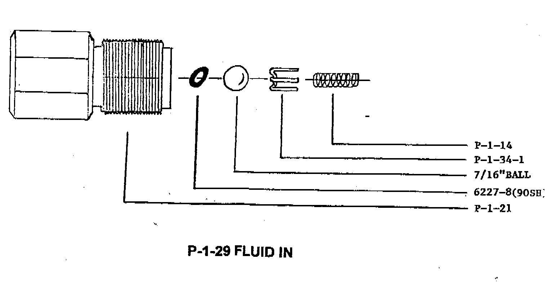
OUTLET VALVE ASSEMBLY (P-1-130): remove the internal parts, inspect and replace required. Remove the o-ring, (6227-890 Shore), inspect the ball seat n the check valve body (P-1-22). If worn or damaged a new body should be used. Install a new o-ring, (6227-890 Shore), replace the internal parts and secure the assembly by installing the retaining ring, (RRT-50).
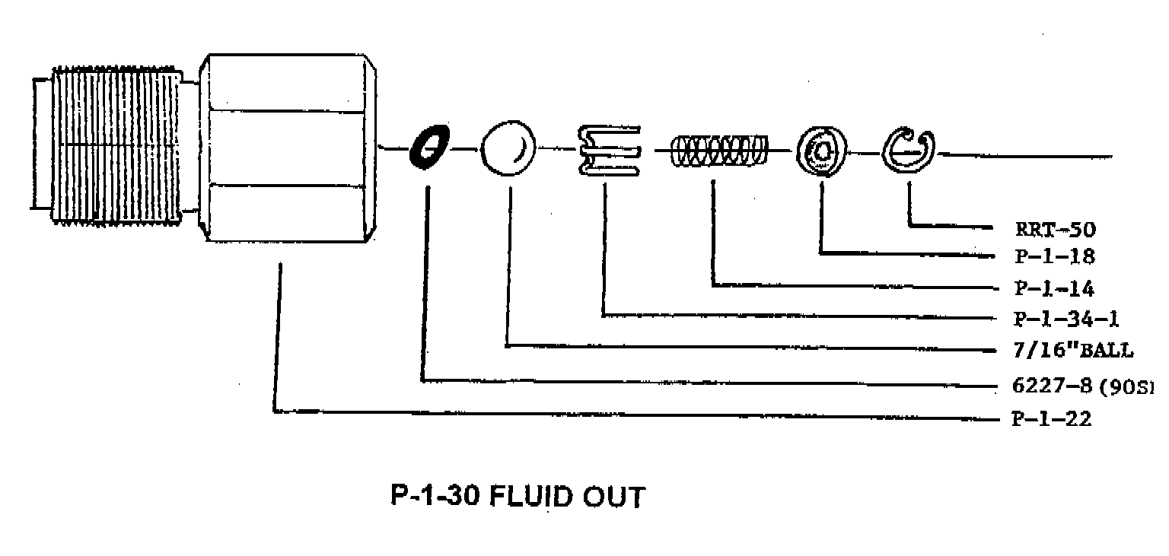
TO REASSEMBLE THE PUMP: it is VERY IMPORTANT when reassembling the Air Motor Assembly to be sure that the Air Cylinder, (P-1-4), is in its proper position against the flanges on the pump head, (P-1-1), and that the air cylinder end. (P-1-7). BEFORE tightening the bolts that clamp together the Air Motor Assembly. Use a soft hammer to position the flanges tightly against the air cylinder, (P-1-4). Bolts should be secured LIGHTLY at first, and then drawn up in sequence until uniform torque has been applied to all eight bolts. (10-12 foot lbs.)

