Galiso Dual Acting Pump
(GDP-10k)

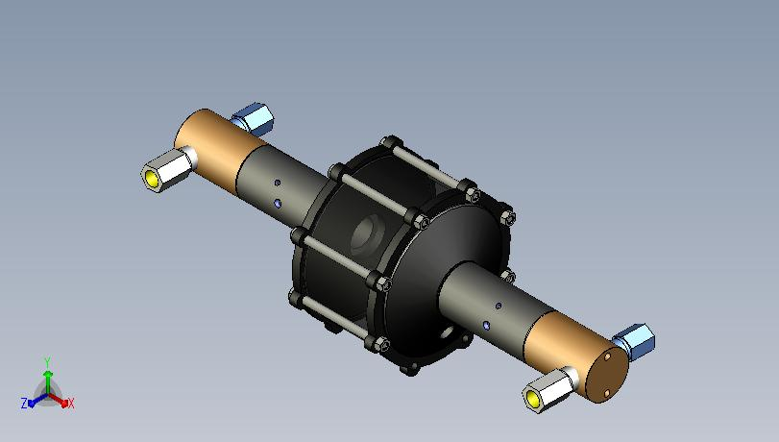

Repair and Maintenance
Component Repair

Parts Explanation

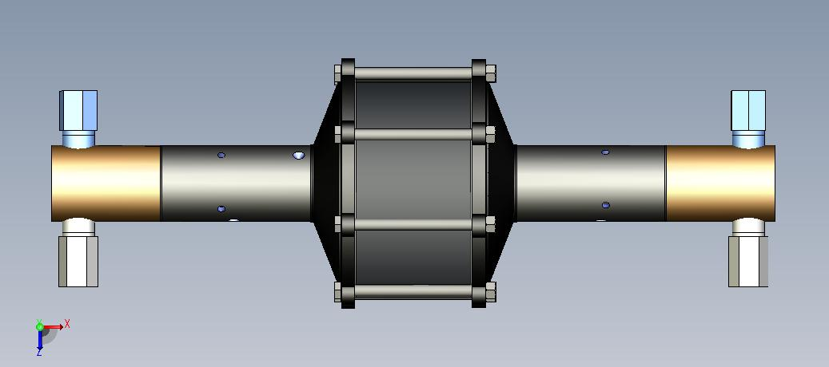
Outlet Check Valve
Isolator Tube
Outlet Check Valve
Isolator Tube
Hydraulic End
Hydraulic End
Inlet Check Valve
Inlet Check Valve

The most common problem in the field with this pump is a drip of water from the isolator tube.
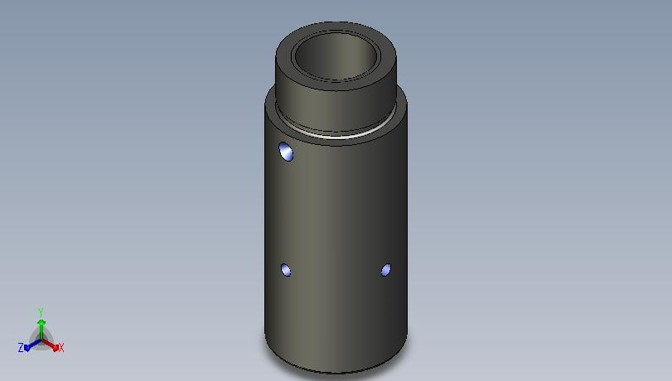
The Water drips from here
This indicates that the seals in the hydraulic end have excessive wear.

Follow these steps to repair

- First remove both the high pressure (9/16 wrench) and low pressure (7/8 wrench) tubing from fittings located on the check valves.
High pressure sst line
Low Pressure Copper line

- Unscrew the hydraulic end assy from the pump
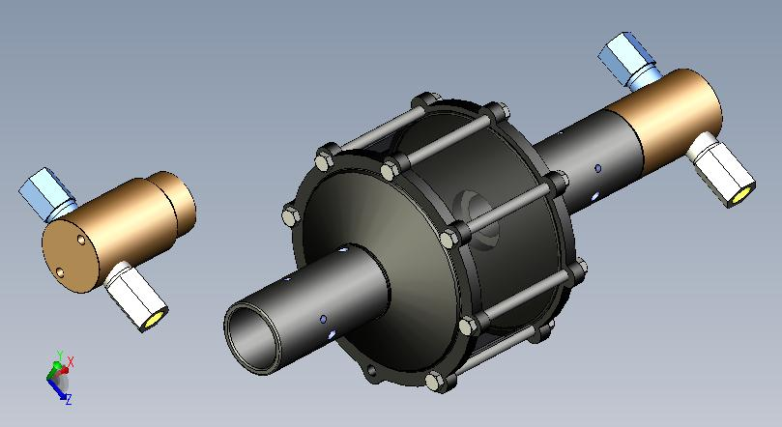
Hydraulic End
- Set upright to pick out the old seals
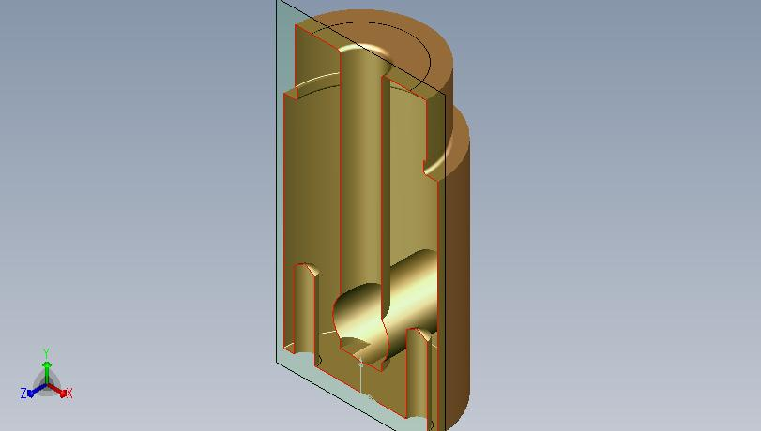
Seals will be located here

- Replace existing seals with new and reassemble the pump (when installed the o-ring should be sandwiched between the two Teflon seals)
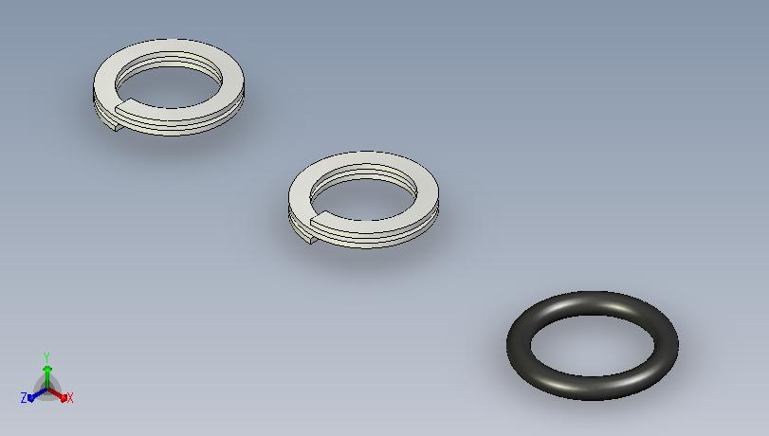

To repair the check valves of the pump:

1. First remove both the high pressure (9/16 wrench) and low pressure (7/8 wrench) tubing from fittings located on the check valves.
High pressure sst line
Low Pressure Copper line

2. Remove check valve
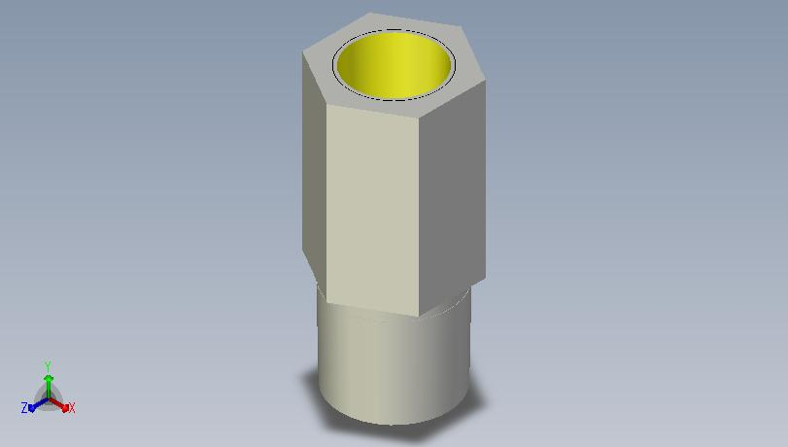
3 The check valve repair kit consists of the following:
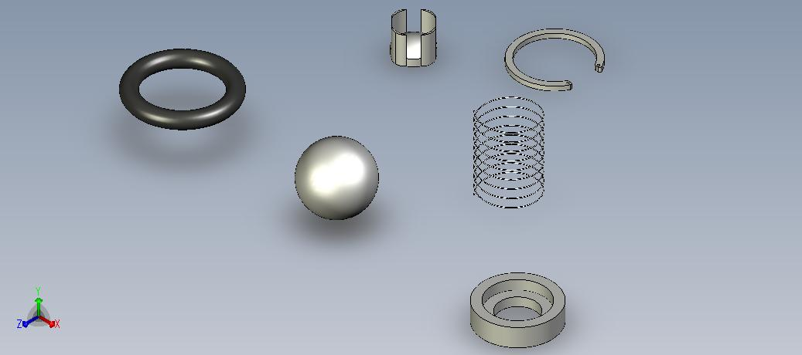
Buna N Oring
SST Check Ball
Spring Retainer
C Style retaining Clip
Spring
Ball Retainer
- Remove C Clip and all Parts.
- Use O-ring pick to remove O-ring
- Replace O-ring, grease O-ring with O2 compatible grease
- Replace all of the hard items and return to service.

To replace the Air seals in the Isolator Tube:
- First remove both the high pressure (9/16 wrench) and low pressure (7/8 wrench) tubing from fittings located on the check valves.
High pressure sst line
Low Pressure Copper line
- Unscrew the hydraulic end assy from the pump
Hydraulic End

- Loosen the 1/8” Allen on the end cap assy and unscrew the Isolator tube
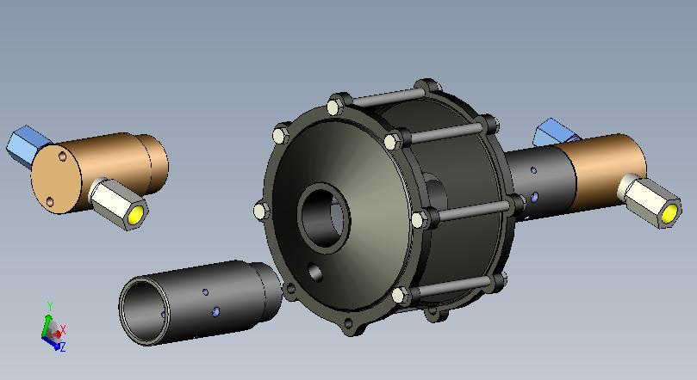
1/8” allen located here
Isolator Tube

4 Remove old seal with o-ring pick
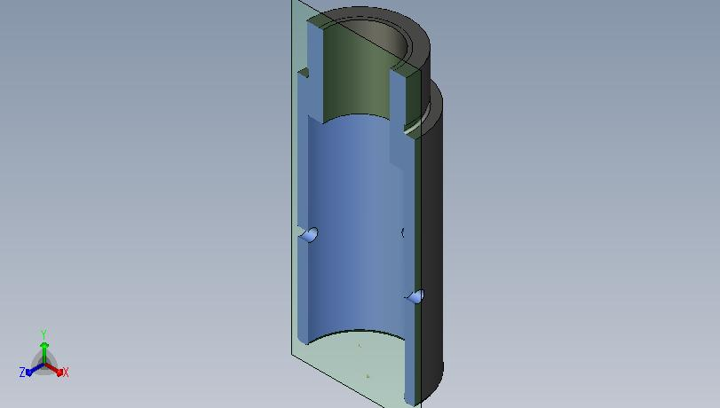
Seals Location
Seal Location
- When installing new seal be sure that the 0-ring is installed into the Teflon backup seal prior to installing in the isolator tube
- Lightly bend in one side of the Teflon Backup/O-ring assy to make a “C” shape and install into the Isolator tube. Be sure that the seals are completely in the groove.

