Sno-Trik Valves

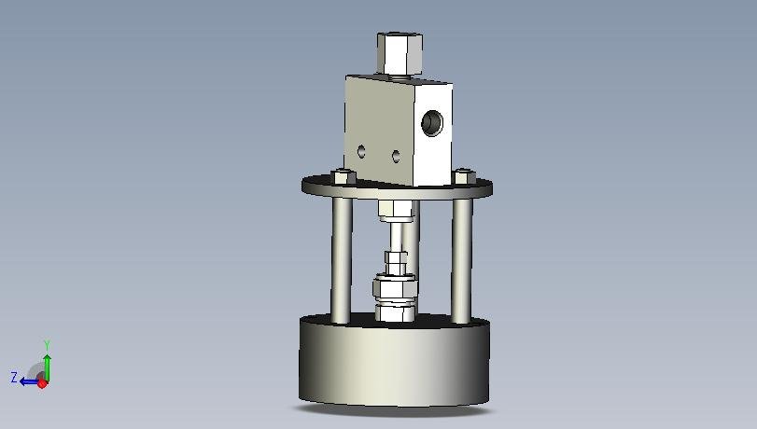

Air operated

Parts Diagram and Repair
Leaks
For leaks around the
bonnet nut (2)
tighten nut 1/8 to 1/4
turn.
For leaks from the
body hole, tighten
water inlet seat (13)

ITEM | DESCRIPTION | P/N | ITEM | DESCRIPTION | P/N
1 | Drive Nut | 81-11-0228 | 8 | Rod Nut | 81-11-0229
2 | Bonnet Nut Sleeve | 81-11-0231 | 9 | Tie Rod (3) | 81-31-0238
3 | Bonnet Nut | 81-11-0230 | 10 | Lock Nut | 62-33-5873
4 | Actuator | 81-11-0197 | 11 | Mounting Plate | 81-31-0239
5 | Spacer | 81-11-0208 | 12 | Packing Gland (2) | 81-11-0132
6 | Packing Ring (2 Req.) | 81-11-0201 | 13 | Replaceable Seat | 81-11-0133
7 | Stem | 81-11-0131
 | Repair Kit * | 81-41-0263

* Repair Kit consists of: 1 Stem, 1 Replaceable Seat and 2 Packing Glands.

Standard Repair Kit P/N 81-41-0263

1 These are the most common repairs in the field typically diagnosed by leaking from the valve body or through the valve itself when closed. The Kit consist of 1ea stem (p/n 81-11-0131) 1ea replaceable seat (p/n 81-11-0133) and 2ea graphite packing gland (p/n 81-11-0132)

2 Disassemble the valve by removing the allen screws behind the round mount plate, then unscrewing the bonnet nut allowing the stainless body to be removed.

3 Once removed you can then remove and replace the replaceable seat and press the old packing glands and packing rings from the valve body.

4 Replace one packing ring (sst ring) then two graphite and finally one more packing ring as to sandwich the two graphite between them.

5 Replace the stem and reassemble taking care to not over tighten the bonnet nut assy, hand tight plus an ¼ turn. (Follow instructions on setting adjustment if needed) If the valve still leaks from the vent hole then tighten an 1/8 turn while not under pressure until leak stops.

Setting the adjustment

1. With the valve off the test system, apply compressed air to the inlet of the Air Actuation unit until it pushes the body up to its full extension.

2. Measure the distance between the shoulder of the tie rod and the base plate of the body. There should be a gap between 3/16ths, and 1/8ths inch.

3. To ensure that the measurement is accurate, apply slight pressure to the top of the body. Pressure must be applied while air is fed to the valve.

4. To adjust, loosen the lock nut and turn the Actuator with your fingertips. You may need to use a 3/8ths spanner to hold the drive nut from turning.

5. This measurement usually involves trial and error. Typically, you may need to pressurize and depressurize the Air operated cylinder a few times. When the proper clearance exists, release the air pressure and securely tighten the hex nuts on the tie rods.

