Technical Bulletin

Subject: Temperature
Introduction
The subject of temperature invariably arises whenever volumetric expansion testing is discussed. Whenever expansion reading changes in a way that is not related to the hydrostatic test itself, the cause must be identified, isolated and removed. Any test system should only be measuring actual volumetric changes due to the cylinder under test, not effects related to the test bench. Temperature differences of only 2°C between the cylinder, the jacket, the incoming water and ambient air temperature can cause erroneous readings, depending on cylinder and jacket sizes. Every system has individual characteristics, so the notes below are intended to assist in the understanding and remedy of these individual problems.
Locate the Problem
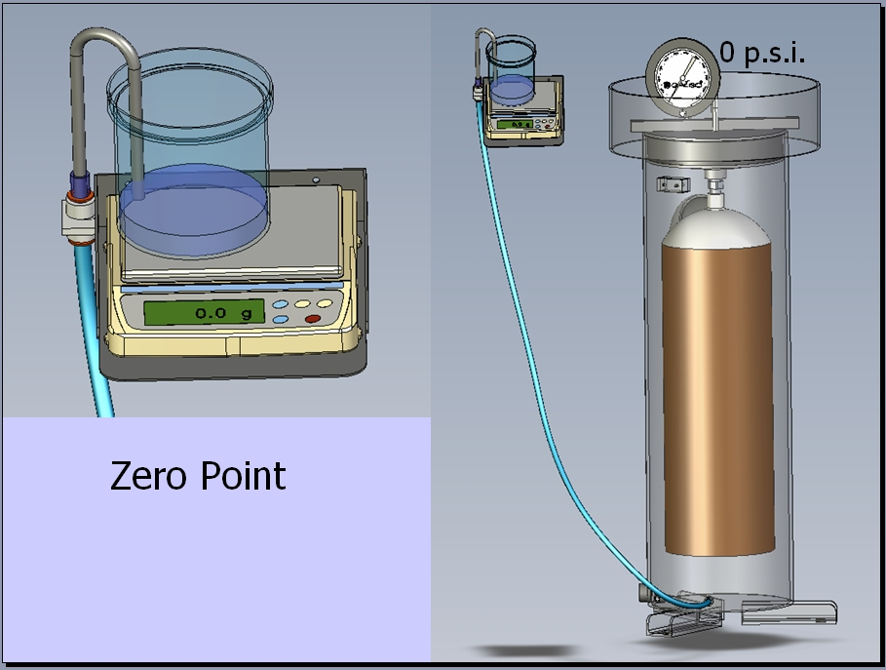
The diagram below shows a typical expansion test set-up. The burette is often replaced with a digital readout from a scale or load cell.

Any investigation of temperature (and therefore expansion) related effects should always be carried out initially at zero pressure. The presence of pressure in the system only serves to complicate and possibly mask expansion effects.
To identify any temperature related problem, load the cylinder into the test jacket, seal the head and log the expansion readings at 30 second intervals in a form similar to the one below: Example readings are shown.
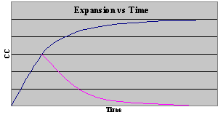
Time Secs | Expansion  reading /cc | Change from last  Reading (± cc)
0 | 0 | -
30 | 1.5 | +1.5
60 | 2.1 | +.06
90 | 2.3 | +0.2
120 | 2.4 | +0.1
150 | 2.5 | +0.1
180 | 2.5 | 0
The graph shows the expansion gradually reaching a steady value. It can be plotted either as the expansion value itself (in which it tends to reach a stable value) or as the change from the last reading - this will tend towards zero. Values could be increasing or decreasing. A straight line or steady expansion change over time represents a leak - not a temperature effect!

What has happened?
The test system comprises a steel jacket full of water connected to a measurement burette or weigh-bowl. Inside the jacket is a test cylinder.
A difference in temperature causes either the steel jacket, or the cylinder within it to expand (or contract). It is the resulting volume change that gives rise to expansion changes that are unrelated to the hydrostatic test.

What to do about it?
Having established that a temperature effect is causing erroneous test results, it is obviously necessary to remove the cause. Some common causes are identified below:

· Room temperature
Variation in room temperature will cause the jacket to change temperature to match.
§ Heating coming on (after the weekend or in the morning?)
§ Heater blowing on the jacket
§ Sunlight coming through the window (after a specific time such as midday?)
Avoidance: Remove the cause

· Drafts
A gust of cold or warm air will affect the jacket causing reading changes.
Avoidance:
§ An open door or window
§ Other machinery blowing onto the jacket

· Incoming Water
Jacket fill water temperature may be different from the jacket temperature which will have reached a stable value at ambient. Cold (usually) or warm inlet water may affect this. Pumped high-pressure water will have a similar effect by altering the cylinder temperature, which will need time to stabilize.
Avoidance:
§ Incoming mains may need to be raised (or occasionally lowered) to room temperature by use of a separate tank in the room or radiator.
§ Fit a temperature compensating valve into the supply line (needs to be often adjusted).
§ If batch testing, test smaller cylinders first and work up to larger sizes. This will reduce the need to use make-up water between tests

· Cylinder temperature
Cylinders under test may have just come in from outside or been filled with cold water
Avoidance:
§ Ensure cylinders are brought-in, in advance
§ Batch fill cylinders in advance of test and allow to stabilize to room temperature – increase size of holding pens to accommodate

New Installations
With a new installation, the opportunity exists to consider and remove the types of problem described. By following the guidelines above, most installations will have removed the major causes of temperature related difficulties.

If the above still does not help, call your local Galiso agent who will discuss your installation. These guidelines will remove the cause in most instances, however, because of the many factors influencing each installation, absolute guarantees are impossible. However, if the problem is temperature related, we can help you find and eliminate it. It can be cured!

