Test systems – a generic guide to selection


Options | Advantages | Disadvantages | Comment
GTC | Low cost  Easy to install and operate | No computer control | 6 to 8 cylinder per hour, available in single or dual jacket configuration
RecOpen | Computerised control, semi automatic including pass fail calculations | Higher cost than GTC but better functionality and performance | 13 to 15 cylinders per hour, available in single or dual jacket configuration
Rec4 Open | Latest generation semi automatic with PLC operation | Higher cost than RecOpen but better functionality and performance | Up to 20 cylinders per hour. Windows based system “next generation” system
RecIII | Galiso's state of the art world-class automated hydrostatic test system.. | Higher cost but significantly faster | Up to 35 cylinder per hour. Console contains a computer with colour monitor, load cell, 18-bit A/D card, and pressure transducer
Rec4 | Latest state of the art system for the serious tester! |  | Very configurable – refer to Bancroft for further details

Test jackets
12” jacket | Accommodates cylinders up to 10” dia
14” jacket | Accommodates cylinders up to 11.25” dia
18” jacket | Accommodates cylinders up to 15.25” dia
24” jacket | Accommodates cylinders up to 21.5” dia
Jacket length | A standard “short” jacket accommodates cylinders up to 32.5” tall  A standard “tall” jacket accommodates cylinders up to 68.5” tall  A custom 5’ (60”) jacket accommodates cylinders up to 50.5” tall, custom cylinder height is nominal pipe length less 9.5”

Options | Advantages | Disadvantages | Comment
Two jacket system | Small jacket used for smaller cylinders assists stability | Additional space and cost | Most commonly used system for aviation testing short 12” jacket and 18” or 24” second jacket for larger cylinders
Stainless steel jacket | Corrosion resistance  Appearance  Ease of maintenance | Cost | It is possible to use a stainless jacket with a carbon steel head
Stainless steel head | Corrosion resistance  Appearance  Ease of maintenance | Cost | It is possible to use a stainless jacket with a carbon steel head
Jacket size | Small jackets more stable if temperature varies | Large jackets less stable if temperature varying | All jackets are the same accuracy (0.1cc), size affects potential stability.
Equipment is capable of operating to meet the requirements of CFR title 49 sections 180 and associated parts. Bancroft can provide advice, training and set-up assistance in obtaining and keeping your DOT accreditation
System |  | Specification
General catalogue index |  | http://www.galiso.com/GalisoWebCat/pg3.htm
GTC Console  Manually tests up to 10-12 high or low pressure cylinders of all types per hour | 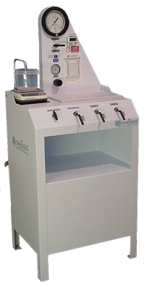 | http://www.galiso.net/GTCModII.htm  The GTC Mod-II is an economical yet full-featured manual test system designed for smaller volume cylinder testing facilities. This test console is economical, easy to use, accurate and reliable.  - Expansion measured with electronic accuracy to 1/10 CC by the EEMS (Electronic Expansion Measuring System) system by LCD display.  - The console footprint is approximately 5 sq. ft.  - Can be configured to a 1 or 2 test jacket system.  - Tests to pressures of 400psi to 10,000pi.  - Use for Steel, Aluminum, Composite Exemption cylinder testing.  - Low maintenance powder coated cabinet  - Highly reliable air driven intensifier pump.  - No cost operator training at the Galiso facility
RTO Console  The Recortest/Open will test up to 15 medium sized cylinders per hour | 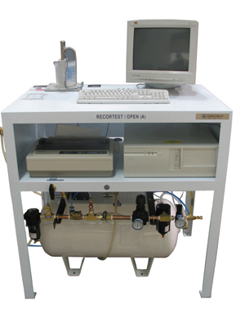 | http://www.galiso.com/GalisoWebCat/pg13.htm  The Recortest Open provides greater productivity and accuracy than is possible with manual cylinder testing equipment because each step of the test process has been automated to save time.  - Data entered by keyboard to validate each test by cylinder type.  - Expandable Cylinder Code Table for Quick Entry  - One keystroke starts and completes the entire test.  - Operator is free to perform other task or prepare another cylinder for the next test.  - Electronic Expansion Measuring System (EEMS)  - Automatic Expansion Calculation  - Pass/Fail results are immediately calculated and displayed.  - Test results are stored on the hard drive and printed onto the Daily Test Log. Now test results are no longer subject to operator interpretation or written errors.

Rec4 Open  PLC controlled with Windows user interface and LAN. Tests up t 20 cylinders per hour with enhanced functionality and ease of use | 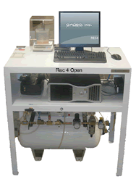  Also available as an upgrade for existing RecOpen users | http://www.galiso.net/WindowsBasedRecOpen/WB-ROS.htm  A proven Windows - based, PLC controlled hydrostatic test system; the REC 4 Open is designed for fast, accurate testing of compressed gas cylinders up to 10,000psi.  Increased productivity: Operator has the ability to add cylinder test data while running the current test  User friendly Windows based software allowing point and click operations  Drop down menus allow for quick data entry of cylinder manufacturers, cylinder codes, gas service and cylinder batches.  17” flat panel monitor, Dell computer, and laser printer  Visual and/or audible system notifications of errors, alerts, cylinder pass/fail and safety issues  Allows for entry of Pass/Fail of “Eddy Current” information  Pass/Fail results are immediately calculated and displayed.  Network capable - connecting to your local Domain or Workgroup network.  Test results are stored on the local hard drive and can also be stored in a centralized corporate network location for backing up and sharing.  Remote support – Galiso is able to operate, service and support networked REC 4 systems from its office in Montrose CO, USA

Test report | 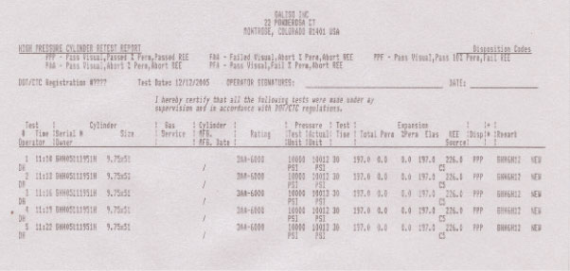 | http://www.galiso.com/GalisoWebCat/pg12.htm - TRS  Each cylinder to be tested includes a log of the cylinder serial number, size, and rating manufacture, date of manufacture, cylinder service, and capacity tested cylinders will have recorded the test pressure, test duration, reject elastic expansion, REE source, and a short character remarks section. Results for cylinders include: total expansion, permanent expansion, percent permanent expansion, elastic expansion and a disposition code that indicates the status of the cylinder at test end

System |  | Specification
RecIII  High Pressure Cylinder Testing Ability--Up to 10,000 PSI. A Pentium Based PC | 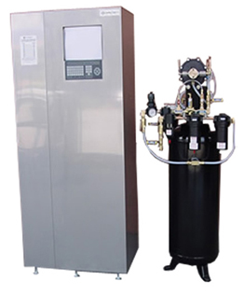 | http://www.galiso.net/GalisoWebCat/pg10.htm  The Recortest III is the heart of Galiso's state of the art world-class automated hydrostatic test system. The console contains a computer with color monitor, load cell, 18-bit A/D card, and pressure transducer. Housed also are the electro-pneumatic and process control valves. These high quality components measure, analyze, record, and print the Cylinder Test Results--making this the most accurate system available to meet DOT test requirements.
Rec4  The latest and most capable system ever built | 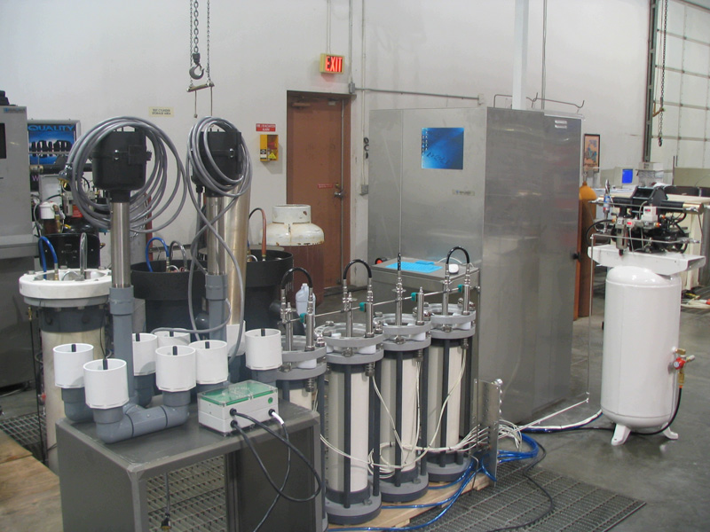 | http://www.galiso.net/Rec4/Rec4JacketSystem.htm - DESIGN  Windows XP professional PC operator interface and data collection computer networked to PLC control and customer network. Automated calibration / digital instrumentation to reduce calibration time and provide improved accuracy, calibration and maintenance. Can accommodate up to 4 jackets simultaneously with precise pressure control
RSP 10  Pump module for RecIII and Rec 4 | 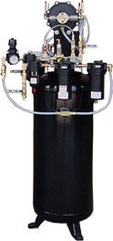 | http://www.galiso.net/GalisoWebCat/pg12.htm  The RSP-10D Recortest III Utility Support Package provides the necessary filtered air, water, and pressurization equipment to perform exceptional hydrostatic testing within the Recortest III System,  Dual actiing 10,000 PSI air operated water pump provides water pressure

System |  | Specification
Test heads and jackets  The GHH, (Clean), and OHH, (Dirty) Hydraclose Test Heads reduce the set-up time for testing by pneumatically sealing the head to the test jacket, and sealing the cylinder test connection | 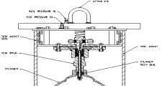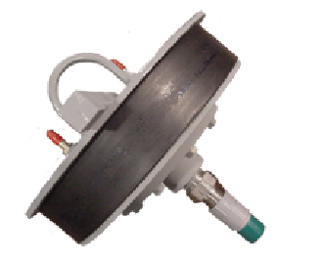 | http://www.galiso.com/GalisoWebCat/pg16.htm  With a slight turn, the test head locks safely into place. The rubber boot portion of the test head expands to create a leak-proof closure when the low-pressure air line is attached. This simultaneously activates a diaphragm to compress the speed seals in the cylinder neck ensuring a fast leak-proof connection.  The GHH (Clean) Hydraclose Test Head is offered for general cylinder testing of "clean" cylinders such as oxygen, specialty gases, or argon where the presence oil contamination is absent.  Standard sizes  12” 14” 18” & 24” diameters.  Jacket Lengths 42 and 84”  Carbon or Stainless steel
GTJ water jacket  Specially designed to accommodate the Hydraclose Test Head | 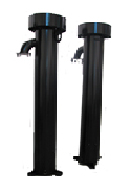 | http://www.galiso.net/GalisoWebCat/pg16.htm - GTJ  The Hydraclose Test Jacket contains a safety locking device, one or more burst disk crystals, (depending on the diameter of the jacket), a drain valve, a splash shield and connection hoses that attach to the Hydraclose Test Head  Jackets are available in overall heights of 48 1/2" (Short) for testing scuba, SCBA, or other cylinders less than 33" in height, and 84 1/2"overall height for testing up to 68 1/2" (Tall) in height. Test Jacket may be custom ordered in specified lengths to fit your application needs

Calibrated cylinder | 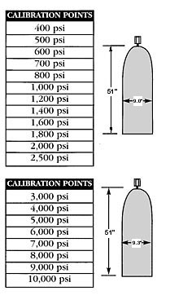 | http://www.galiso.com/GalisoWebCat/pg18.htm  Galiso supplies calibrated cylinders in 2 size groups; SCC (short Calibrated Cylinder), and LCC (Long Calibrated Cylinder)  In accordance with D.O.T regulations, hydrostatic test systems must be checked daily to assure the accuracy of the test results. The calibrated cylinder is a special steel or aluminum cylinder with a predetermined expansion rate, which is calibrated by Galiso, to be used to check the precision of the hydrostatic test system expansion readings.  FEATURES  Galiso calibrated cylinders are specially prepared to provide years of dependable service. Each calibrated cylinder is pre-stressed to eliminate permanent expansion and protect calibration points.  The calibration run is checked by a specialized computer program to ensure the linearity of calibration points .  A Stainless steel adapter is included to protect the cylinder neck threads and prolong the life of the calibrated cylinder
Master Gauge | 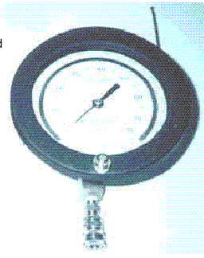 | http://www.galiso.com/GalisoWebCat/pg20.htm - MAG  The Master Gauge Assemblies are used for the verification and calibration of the pressure transducer on the Recortest III and Recortest/Open Systems. A Master Gauge Assembly may also be used to extend the recalibrating period for an Analog working gauge to 1 year--instead of 6 months.  FEATURES  The Master Gauge Assembly features a mirror dial face and a fine pointer needle for increased accuracy and legibility.  The Master Gauge Assembly also includes a Calibration Certificate.  All Galiso Mater Gauge Assemblies are certified as having a quality rating (0.25% ) of full-scale accuracy

System |  | Specification
Optilite and black light | 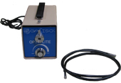  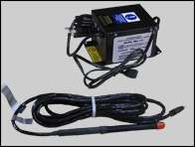 | http://www.galiso.net/GalisoWebCat/pg32.htm  The Opti-Lite is a fiber optic projected light system used to inspect the interior of compressed gas cylinders for pitting, cracks, rust and/or corrosion. Fiber optic light transmission delivers maximum brilliance inside the cylinder.  FEATURES  The Opti-Lite provides a margin of safety. Since light is transferred through glass fibers, all heat and electrical current is isolated from potentially flammable gases within the cylinder. The fiber optic illuminator cable is encased in a rugged, silicone wrapped flex line for increased durability.  CAUTION – Guessing is hazardous to your personnel! Was the oxygen or breathing air cylinder you just tested exposed to hydrocarbons (oil)?  FEATURES  The Black Light Kit confirms oil residue in a cylinder by inserting the  ultra-violet light-emitting probe into the cylinder to inspect the neck and interior walls.  Any trace of hydrocarbons become readily visible by appearing white, in sharp contrast to the purple Illumination generated by the light probe.  When the Black Light Kit is in use, UV coated safety glasses are recommended.  The probe cable is 12 feet in length making it easy to inspect cylinders of all sizes, yet can be stored out of the way or wall mounted for convenience
Visual plus | 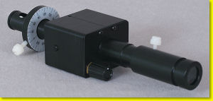 | The newest, brightest, and most powerful optical instrument for cylinder inspection  OpticalPlus has the highest magnification (4X), clarity and lighting capability available - surpassing anything you have used in the past.  OpticalPlus provides full vertical adjustment and 360-degree rotation within the threads. This allows for perfect alignment between the instrument and threads for ease of use and performance during inspection

System |  | Specification
HDD-8 | 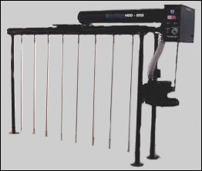 | http://www.galiso.com/GalisoWebCat/pg27.htm  HDD driers feature a thermostatically controlled 8KW heating element. A 1.5 HP (1125 watt) brushless regenerative blower motor moves hot air through each cylinder at 106 CFM.  The brushless motor provides quiet, maintenance free operation without the need to periodically replace worn brushes.  The blower assembly features a convenient 110 Volt outlet to operate the Galiso Opti-Lite for timely inspection of cylinders.  The HDD driers are thermally insulated to assure maximum heating efficiency.  HDD driers are shipped partially assembled with easy-to-follow set-up instructions.  Use for Steel, Aluminum, Composite, and Exemption cylinder testing
GCD-4 | 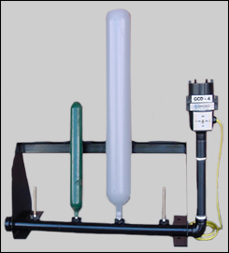 | http://www.galiso.com/GalisoWebCat/pg29.htm  FAST, EFFICIENT, LOW COST. Ideal for Medical D & E's, SCBA's, Scuba and small CO2 cylinders.  FEATURES  Powered by a heavy -duty blower, the GCD-4 generates 95 CFM of hot or cold air to efficiently dry small cylinders.  Drain, invert and place up to 4 cylinders on the drier probes.  Cylinders are properly dried in a matter of minutes, ready to be inspected and placed back into service.  The built-in drier motor is quiet, producing temperatures to 175°F to accelerate the dying of steel and aluminum cylinders.  Select the "cool" setting to protect fiber wrapped or composite cylinder, or to simply refresh others.
GCI with IDS | 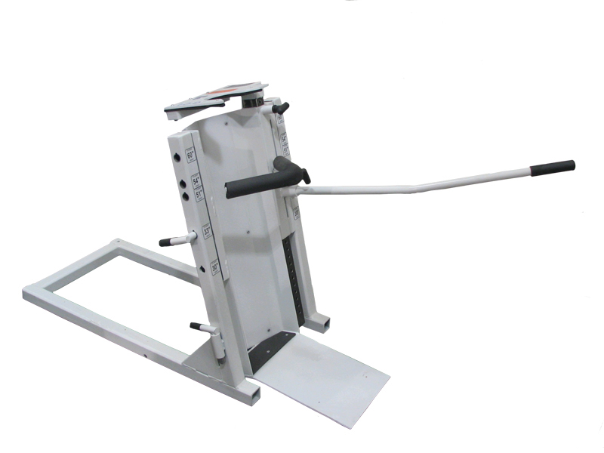 | http://www.galiso.com/GalisoWebCat/pg28.htm  The new GCI/IDS manually inverts, drains and dries cylinders from the short 20 lb. CO2, SCBA and scuba to the largest industrial cylinders like the 100 lb. CO2  The GCI has a 5 selectable pivot points and a locking containment arm to provided balance and safety to avoid injuries that can occur when employees use makeshift cylinder handing equipment. The small footprint conserves workspace so the GCI can be located near the test station to maximize time and labour savings.  OPERATIONS  The GCI is available with the IDS wash/dry feature that serves as a cylinder drying station, converting the GCI into a duel function support product.  Load a cylinder onto the compact GCI/IDS to invert the cylinder, insert the air/water probe into the cylinder neck and –  - A burst of air purges test water from the cylinder  - Hot water is injected to speed drying  - Another burst of air "flash dries" the cylinder, so in minutes it is dry and ready for final inspection  Convenience at low cost. Affordable to the smallest test facility with limited budgets.
SCD-4 | 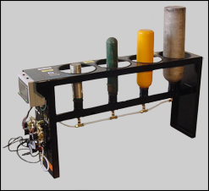 | http://www.galiso.net/SCDSmallCylinderDrier.htm  The Improved SCD Small Cylinder Drier is being reintroduced for the automatic water purging, washing and drying of cylinders not to exceed 7" diameter and 36" in height.  The purge, wash, and dry cycles are controlled electronically, with cycle timing set by the operator to match the cylinders size being dried.
PCT-15 | 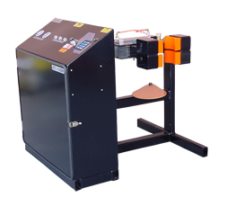 | http://www.galiso.net/GalisoWebCat/pg53.htm  The PCT-15ADW is a single cylinder Inverter Drier. The PCT-122 ADW inverts and dries 2 cylinders per cycle.  Filtered air in injected into the inverted cylinder, purging out water from the hydrostatic test. To rapidly heat the cylinder walls, hot water (180°F) is introduced into they cylinder, followed by a final burst of clean air to produce a 'fresh dried' cylinder ready for inspection  FEATURES  The PCT/ADW (Automated Dry & Wash) models can invert, wash, drain, and dry up to 2 water-filled cylinders in 3 minutes or less depending on cylinder size.  The PCT/ADW is microcomputer controlled, freeing the operator to perform other duties during the purge/dry process.  The time value for any cycle is easily programmed via the keypad to match the cylinder sizes or for particular applications.  The PCT/ADW makes efficient use of workspace by eliminating the need for a cylinder vise, dump rack, and hot air drying manifold.  NOTE: The PCT/ADW Inverter Drier requires a Commercial Hot Water heater capable of supplying 180° water and having a minimum capacity of 90 US gallons

System |  | Specification
PCT-122 | 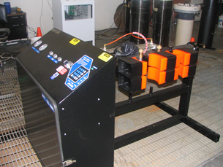 | http://www.galiso.net/GalisoWebCat/pg54.htm  A 2 cylinder version of the PCT15
GVM | 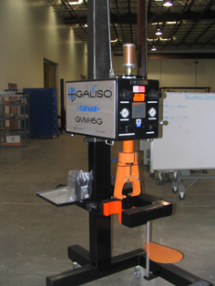 | http://www.galiso.com/GalisoWebCat/pg22.htm  The GVM-16G Turnair Valving Machine removes and installs cylinder valves quickly and efficiently. This GVM workhorse continues to serve users with an unprecedented record of reliability and is legendary in the cylinder maintenance workplace.  A powerful high quality Air Motor ensures long life and maintenance free operation  The patented Valve Tongs automatically adjust to grip valve flats from 7/8" to 1 7/8".  The Valve tong assembly features a power multiplier to increases grip strength as torque increases to hold the valves securely from removal or insertion. This eliminates slippage and valve damage caused by conventional methods.  Cylinders can be left or right side loaded (optional) into the GVM-16G for fast handling.  Available in 2 models: Caster mounted for portability, or mounted on a stationary base plate
Belt Vice |  | http://www.galiso.com/PneumaticCylinderBeltVise.htm  The Belt Vise is a well-constructed, base-plate mounted pneumatic cylinder vise, a must for those shops where an efficient means of valve removal is critical to testing and maintenance.  FEATURES  The non-slip durable rubber belting eliminates cylinder scratching, and prevents cylinder movement while performing the valving and devalving operations  The standard 28" length belt adjusts to fit and firmly grip 4-1/4" to 10-5/8" diameter cylinders. A handy tool and stamp tray is conveniently mounted on the vise.  OPTIONS  An optional 60" belt is available for gripping cylinders up to 15" diameter
Air Hoist | 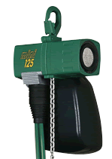 | http://www.galiso.net/GAHAirOperatedHoist.htm  GMAH (Galiso Mini Air Operated Hoist) is an air driven hoist that is preferred to meet the high production rate of the Recortest III Test System, and is also ideal for the Recortest/Open and the GTC Test Systems.  The GAH comes with a standard 10 foot chain assembly.  The GAH Hoist Assembly includes a chain basket and Trolley Assembly  The GAH is capable of lift speeds up to 130 feet per minute,
Cylinder fill  RCSG | 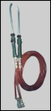 | http://www.galiso.com/GalisoWebCat/pg33.htm  Galiso fill systems rapidly and automatically fill cylinders with water in preparation for hydrostatic testing. The RCSG is designed for smaller capacity cylinders.  The Galiso cylinder fill systems are economical, simple to operate and easy to maintain.  The RCSG is available in configurations of 1, 2, 3, 4 spouts, for quickly filling cylinders.  Each configuration is shipped ready to install, with a 10 foot hose and regulator.  OPERATION  As simple as inserting the spout into the cylinder neck and triggering the start lever. The RCSG will fill the cylinder and automatically shut off when the cylinder is full. This frees the test operator to perform other test-related duties while the  cylinder is being filled.  10' Hoses …………………………………11 1/2' with fill gun  Water Requirements …………………….30 PSI to 50 PSI Maximum RCSG  Flow Rate RCSG ………………………..2 GPM per nozzle @ 50 PSI  Minimum Neck Size ……………………..RCSG 11/16" ID
Cylinder fill CFN | 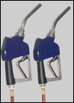 | http://www.galiso.com/GalisoWebCat/pg33.htm  The CFS is designed for large neck, large volume cylinders. The CFS is available in configurations of 1 or 2 spouts for quickly filling a large quantity of cylinders. Combining with an RCSG is also available. Each CFS is shipped ready to install, with a 12 foot hose.  OPERATION  The RCSG fills the cylinder and automatically shuts off when the cylinder is full. This frees the test operator to perform other test-related duties while the cylinder is being filled.  CFS ....................................................................... 12' Hoses, 13' with fill gun  Water Requirements ................................ 30 PSI to 80 PSI Maximum CFS  Flow Rate CFS ....................................................... up to 12 GPM @ 80 PSI  Minimum Neck Size CFS ................................................................ 7/8" ID

